Haskell Question Set 3
1) Give an example where div and quot return different answers. Which is equivalent to Java's integer
division?
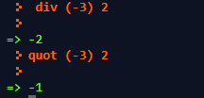
quot

2) Give an example where rem and mod return different answers. Which is equivalent to Java's
modulus?
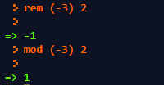
mod
3) Explain divMod and quotRem and give example calculations.
divMod returns a tuple with the first value being the result of integral division, and the second value is the result of modulus.
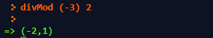

quotRem returns the result of integer division and the remainder
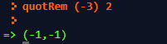

4) What does the ^ do when repeated?
Try: 3^2
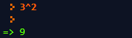

3^2^1
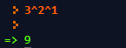

3^2^2
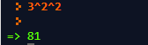

3^2^3
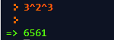

3^2^4
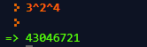

3^2^5
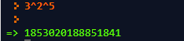

When the ^ is repeated, the math works backwards. For example, in 3^2^2, the 2^2 happens first, and then the 3^4 happens

5) Research time:
What main class type can use max and min?
Ordered
What other methods are available for this data type?
All methods except IO Methods (sum, div, mod, subtract, even, odd, gcm, gcd, etc.)
What main class type can use ==? Eq
What is the opposite of ==? /=
Give an example of using subtract, even, odd, gcd, lcm, ^, ^^.
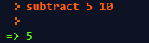
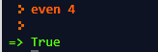
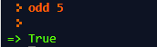
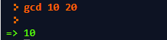
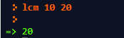
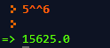
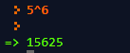
6) Generate the first 20 results of the algebraic results for x^3 - 3x^2 + 3
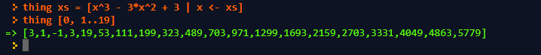
7) Grab the first 10 numbers beyond 500 which are perfectly divisible by 42.
8) Write a function which given three numbers, a, b, and c, calculates all numbers from a to b which are
multiples of c. However, if b is less than a, do the same thing but calculate all numbers from b to a
which are multiples of c.
9) Write a function which accepts a list, x and a number, x, and returns a list of values in x which have no
common divisors with x aside from the number 1. 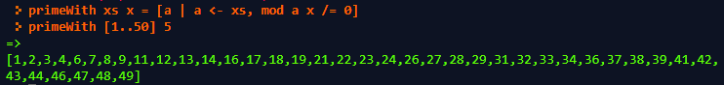
10) Write a function to be used at a high rise hotel, where the owner wants all floor numbers from 0 to
whatever they decide as the top most floor, except they do not want floor 13 to exist (unlucky). 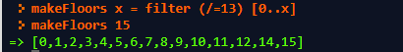
11) Calculate the sum of all results from the expression 27x^2 - 12x - 20 starting at x = 0 and ending at x
= 1000.
12) Write a function which calculates the number of divisors any given value has. For instance, the
number of divisors in 12 = 1,2,3,4,6,12 = 6 total numbers. The number of divisors in 3 = 1,3 = 2 total
numbers.
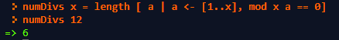

13) Write a function that given a sentence, replaces all spaces ' ' with underscores '_'.
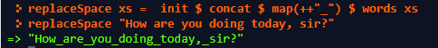
14) Write a function which, given a sentence and a phrase, inserts the phrase after each character in the
sentence. For instance: "That hurt" and "Ouch!" -> "TOuch!hOuch!aOuch!tOuch!
Ouch!hOuch!uOuch!rOuch!tOuch!"
15) Write a function which generates every matrix combination in a 9x9 matrix. -> "(0,0)", "(0,1)",
"(0,2)", ... "(1,0)", "(1,1)"... "(9,9)". Hint: show will convert an int to a String, so show 5 -> "5" 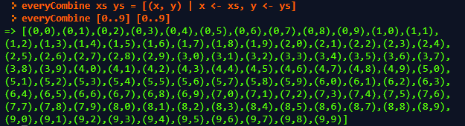
16) Modify the adjective/noun example to accept a list of adjectives, nouns, and build a list with every
combination of adjective->noun you can but only include ones where the adjective and noun begin with
the same letter. "lazy frog" would not be included, but "lazy llama" or "cool cat" or "dirty dog" would
be. 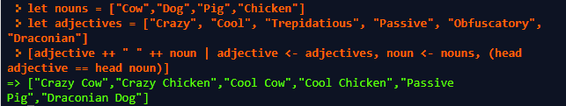
17) Write a function which given a start year and an end year generates every leap year between the
two. Leap years are all multiples of 400 or are all multiples of 4 which are not multiples of 100.
